**Module 3 Assignment For Transformation of Production Data Warehouse As as a Source**

Following steps were done:

1. **Adding constants for Error Messages and Success Column in W_Lead_F Table**

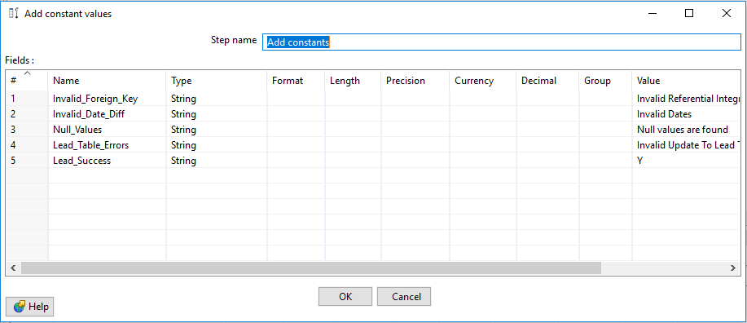

1. **Checking for NULL VALUES (Filter Rows)(Add rejected rows into W_ERROR_LOG)**

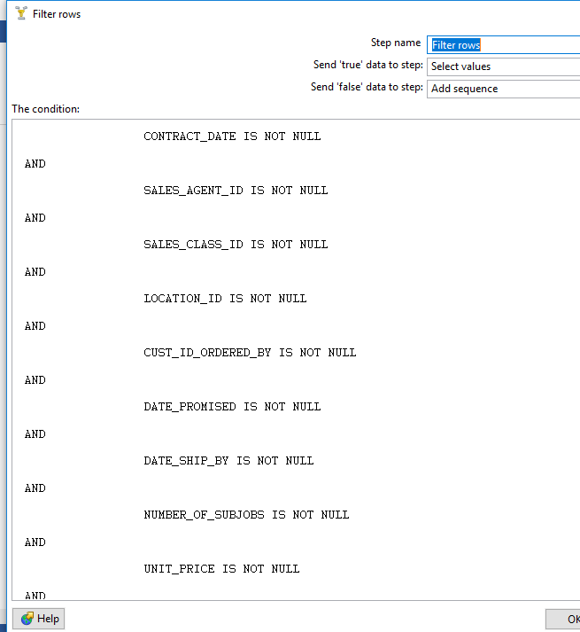

These are added in W_ERROR_LOG

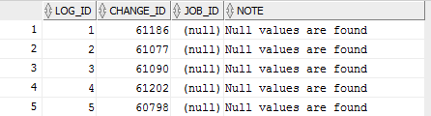

1. **Parsing of Dates is done(Using Select Values and Split Fields For Contract Date,Date_Promised,Date_Ship_By)**

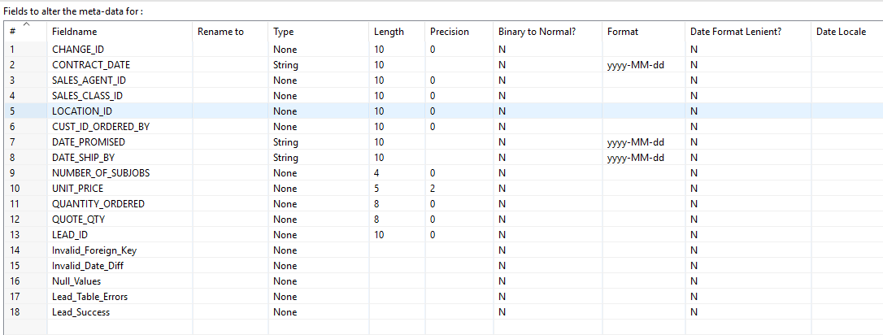

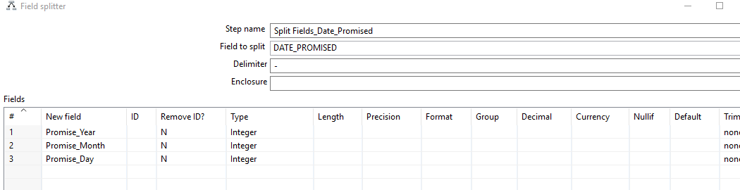

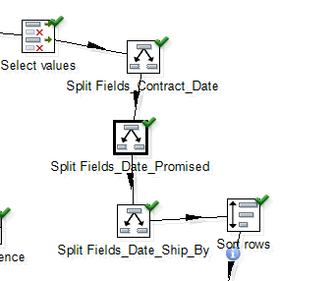

1. **Find Time_Id from Time Dimension For each of three dates**

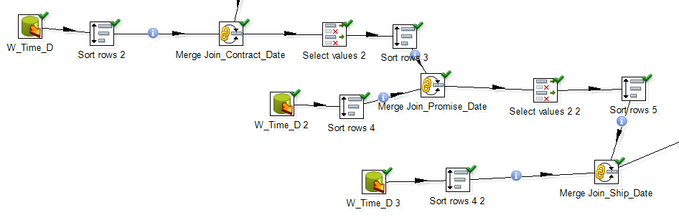

1. **Calculate Date Diff**

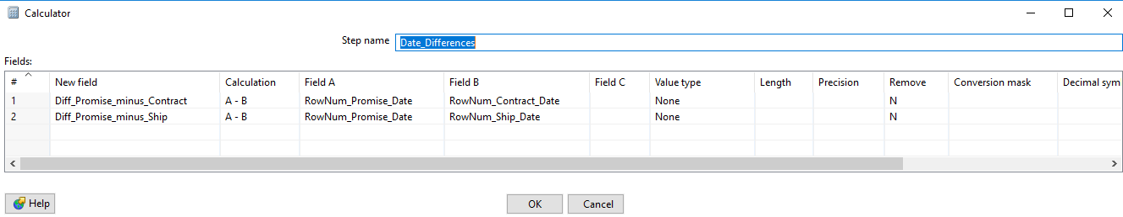

1. **Invalid Date Diff(Add to Error_Log)**

**Filter by Condition and Add non matching rows**

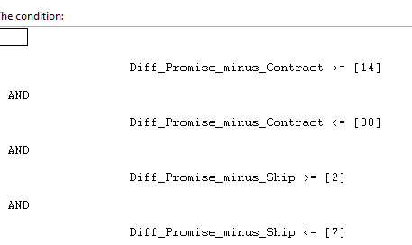

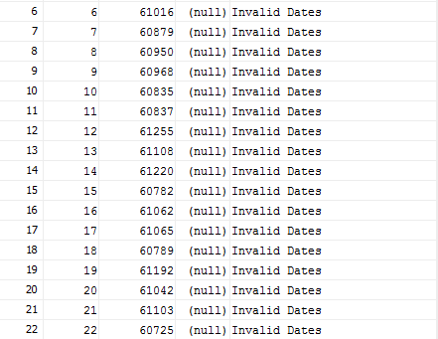

1. **Check FKs For Location_ID, Customer_ID Ordered By,Sales_Agent_ID,Sales_Class_ID**

For Getting Rejected Rows , Do a left outer join for each merge with Tables Input.

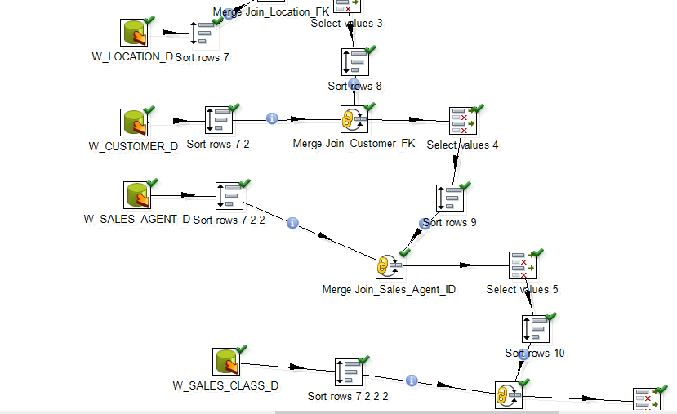

1. **Where FK’s Values are not matched(Add to ERROR_LOG Table)**

**Conditions are used to find non matching rows**

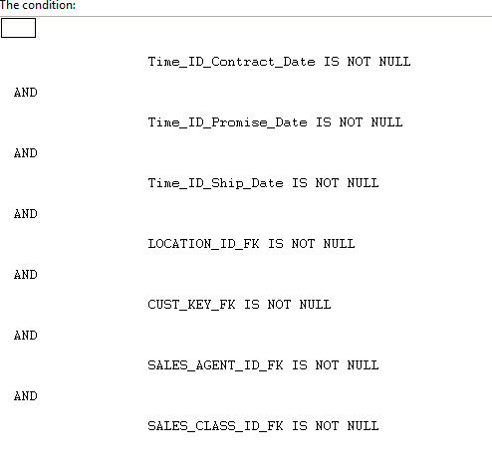

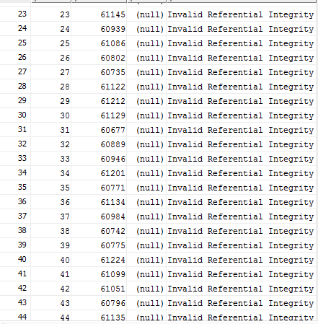

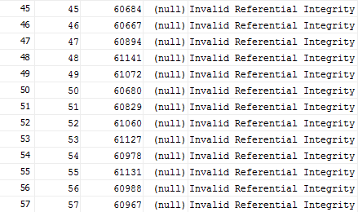

1. **Now add the rows which satisfied the above conditions to Job Table**

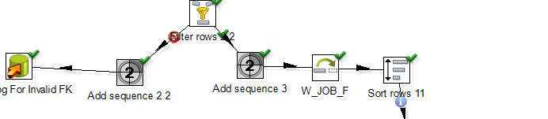

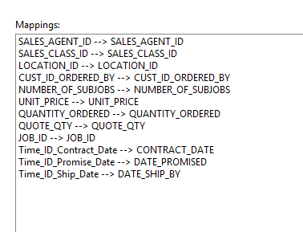

Updated Job Table(543 rows are added)

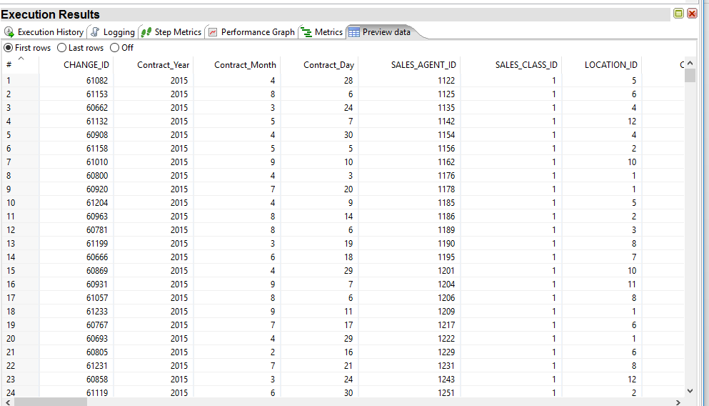

1. **Lead Validation(Now using the added rows in Job Table) (Check for Lead_ID(Validity By Merging with Lead Table) &Checking Created_Date in Lead Table before Contract Date in Job)**

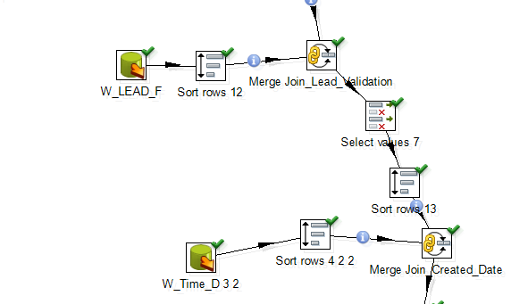 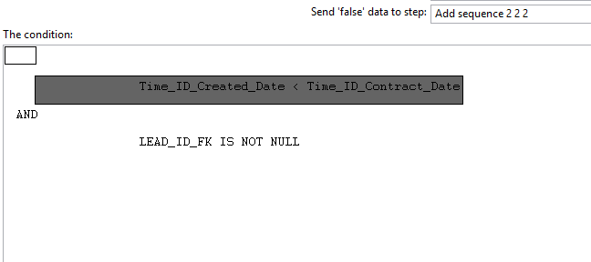

1. **Using this filter condition , adding false rows to Error_Log_table**

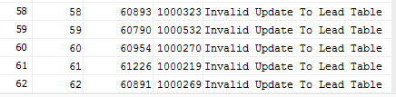

1. **Finally rows that satisfy all conditions(pass all validations are used to update the Lead Table)**

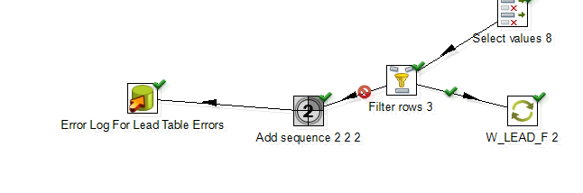

**538 rows are updated**

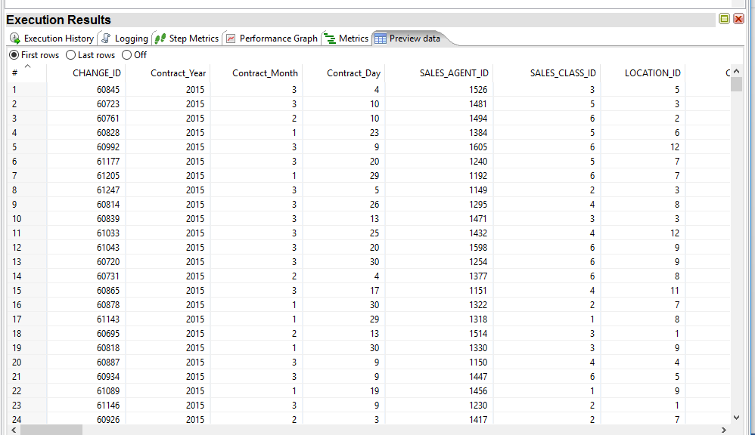

1. **Final View of W_LEAD_F(3600 rows)**

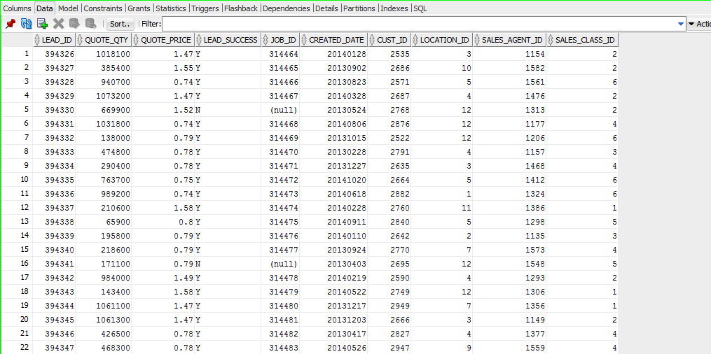

1. **Final View of W_ERROR_LOG(62 rows)**

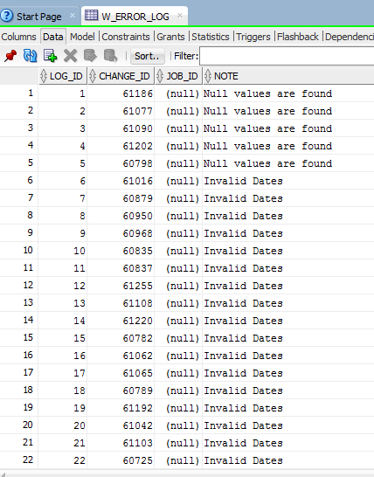 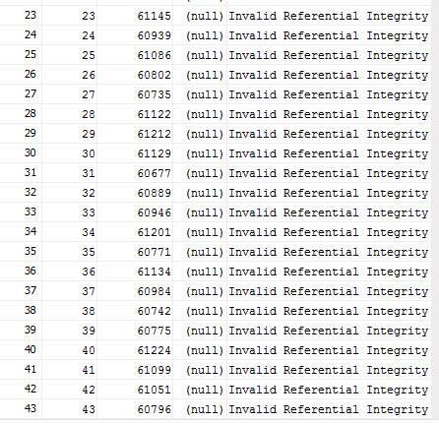

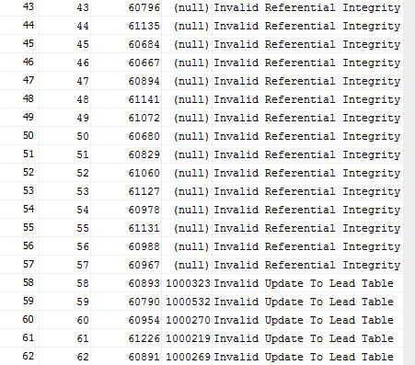

1. **Final View of W_JOB_F (3070 rows)**

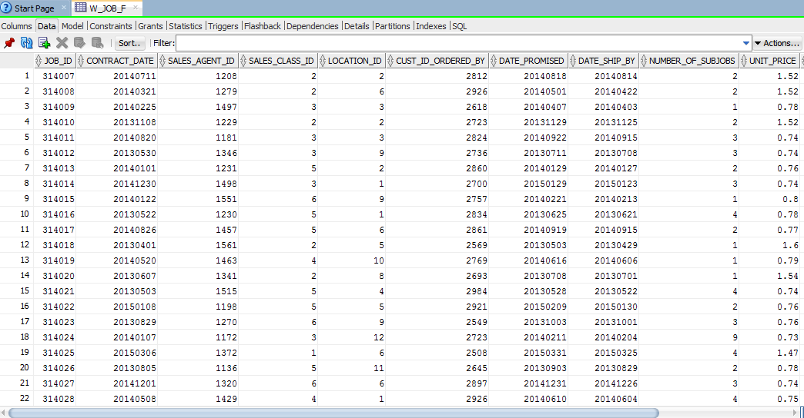

**Transformation is as follows:**

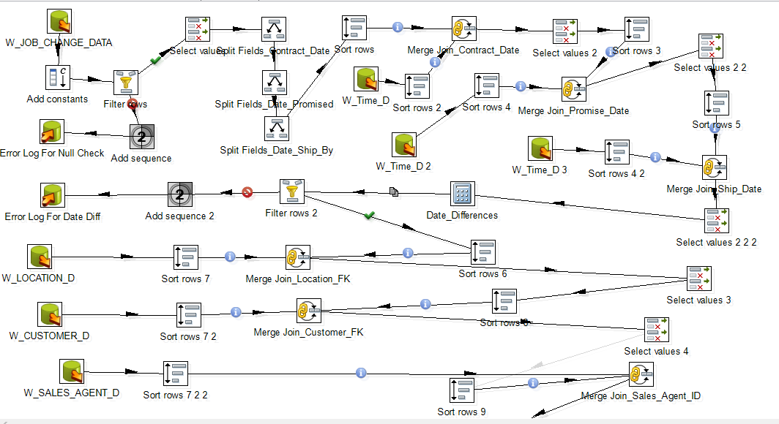

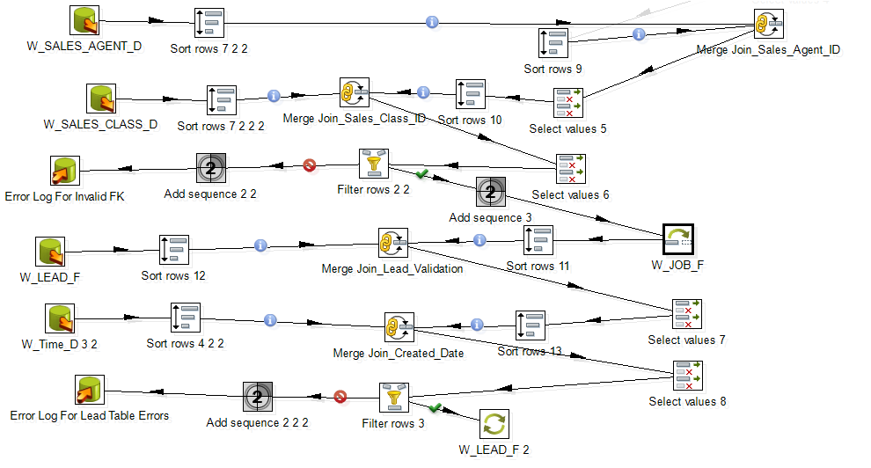

**Execution Results are as follows:**

